1. Using any TCP simulation method (Python / ns2 ), simulate TCP Reno behavior for the following three network conditions:
Packet Loss Cases:
- 0.5% loss
- 1% loss
- 3% loss
For each loss case, perform the following tasks:

Task 1: Plot cwnd vs Time
Simulate a TCP Reno connection for 15 seconds (instead of 20 for simplicity) and plot:
- Congestion Window (cwnd) on Y-axis
- Time (seconds) on X-axis

Task 2: Calculate Throughput
For each packet-loss rate:
- Compute the average throughput in MSS/second or Mbps
- Use any formula (simulation-based or Mathis formula)

Task 3: Explain TCP Reno Behavior
For each loss level, explain what happened in terms of:
- Slow Start
- Congestion Avoidance
- Multiplicative Decrease (cwnd halving) after packet loss

Task 4: Compare the Three Cases
Write a short conclusion comparing the results:
- How does increasing loss reduce cwnd?
- How does it lower throughput?
- Why does Reno take longer to recover after high loss?
--------------------------------------------------------------------------------------------------------------------

2. A process is a program in execution.
In a real operating system, processes arrive at different times depending on user activity, I/O completion, or system load.
The First Come First Serve (FCFS) scheduling algorithm always selects the process that arrives first.
If there is a gap between the completion of one process and the arrival of the next, the CPU remains idle, and your program must correctly account for this idle time.

Scenario
A system is running multiple processes submitted by different users.
The CPU receives the following processes in a non-ordered (random) manner:
Process | Arrival Time | CPU Burst Time
P1 | 4 | 6
P2 | 1 | 3
P3 | 7 | 2
P4 | 0 | 4
P5 | 5 | 5
The operating system uses Non-Preemptive FCFS Scheduling.

Tasks
(1) Write a program to implement FCFS scheduling
Your program must:
- Input AT and BT for each process
- Sort processes in ascending order of arrival time
- Handle CPU idle time (if the next process has not yet arrived)
- Compute:
  - Completion Time (CT)
  - Turnaround Time (TAT = CT – AT)
  - Waiting Time (WT = TAT – BT)

(2) Output Requirements
Your program must print:
- A properly formatted FCFS result table
- Total TAT and WT
- Average TAT and WT
- Gantt Chart showing idle time if present

(3) Manual Calculation Task for Students
Before running the code, students must manually:
- Order processes based on arrival time
- Show how CPU becomes idle when needed
- Compute CT, TAT, WT
- Draw the Gantt Chart
- Verify with program output
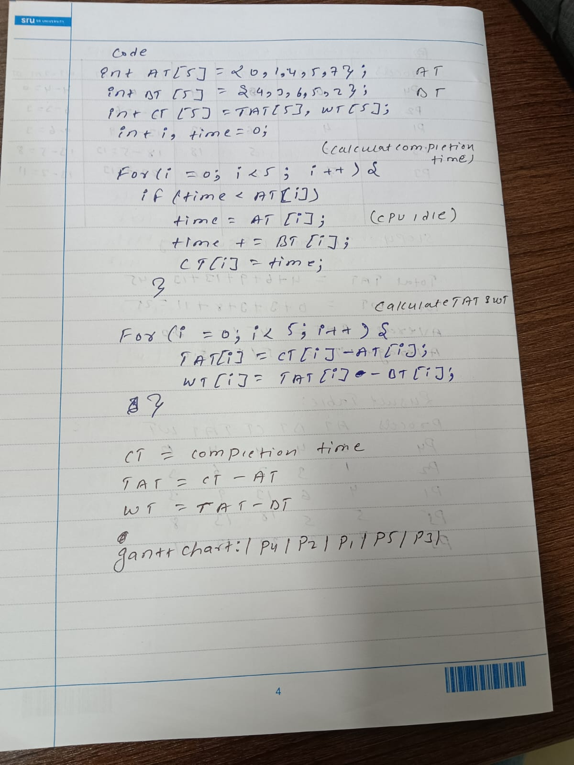
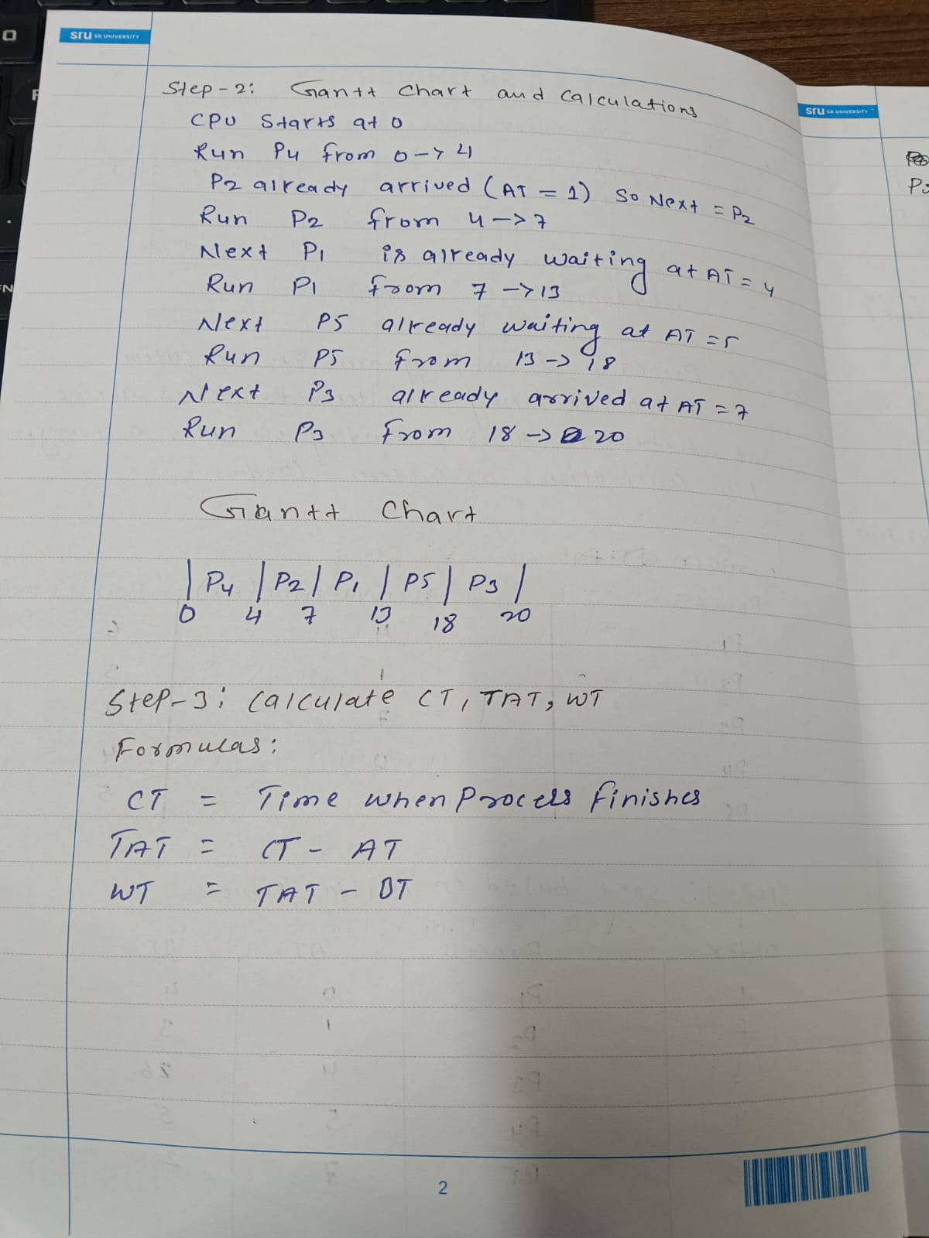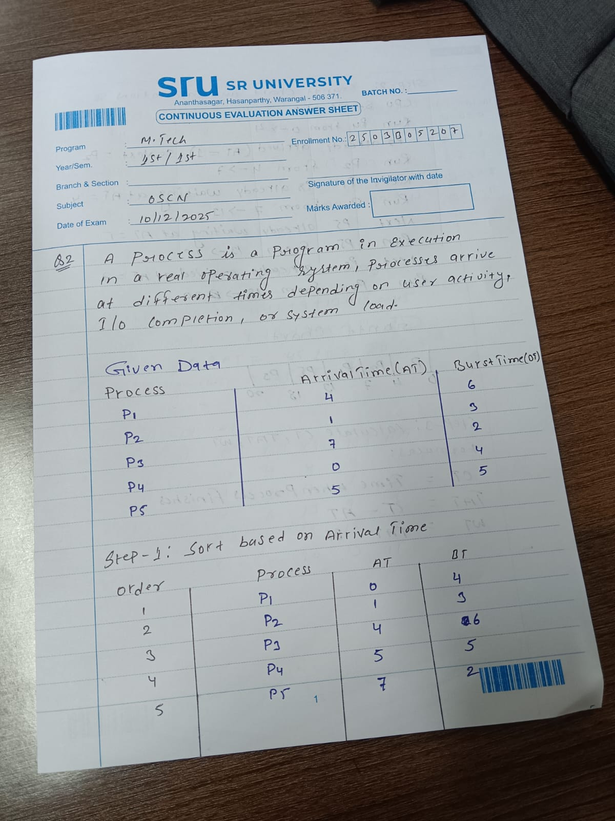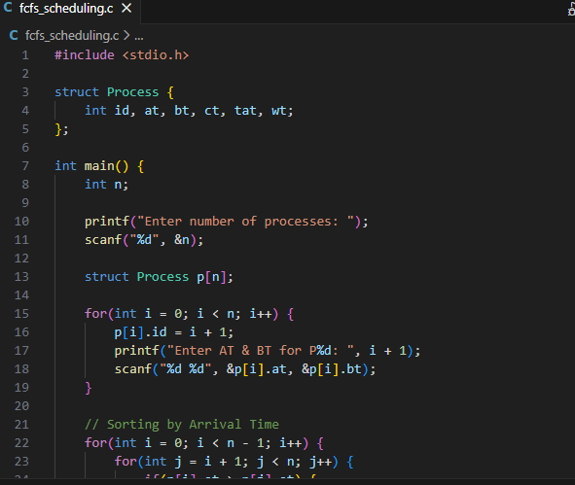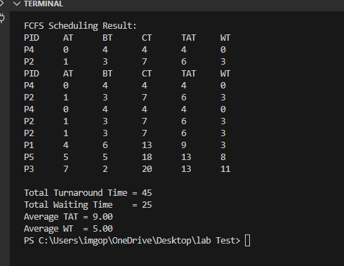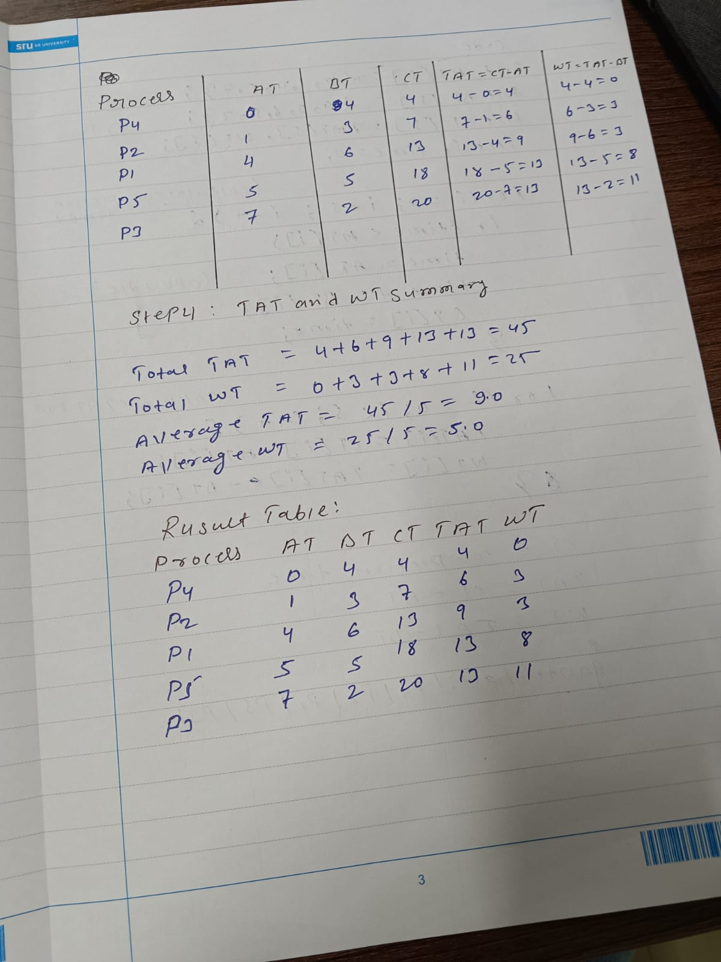
---------------------------------------------------------------------------------------------------------------------
3. A system uses Round Robin CPU Scheduling with Time Quantum = 4 ms.
The following processes arrive at different times (not in order):
Process | Arrival Time | Burst Time
P1 | 3 | 9
P2 | 0 | 5
P3 | 4 | 2
P4 | 1 | 7
Tasks
1. Manual Simulation
Using RR (Time Quantum = 4 ms):
- Draw the Gantt Chart for CPU execution order.
- Compute:
  - Completion Time (CT)
  - Turnaround Time (TAT = CT − AT)
  - Waiting Time (WT = TAT − BT)
2. Program Execution
- Write or run your Round Robin C program.
- Generate the output table.
3. Comparison
- Compare manual results vs program results.
- Write a short reason if there is any mismatch.

